**Genghis Khan Reading Handout**

The Mongol Empire was one of the largest empires in history, stretching across Asia and into Europe. It was founded in 1206 by Genghis Khan, who united many Mongol tribes into a powerful army. The Mongols were nomadic people, meaning they moved from place to place instead of living in one spot. They lived in round tents called yurts, which were easy to set up and take down. Horses were extremely important to their way of life—they used them for travel, hunting, and war. With their skilled horseback riding and strong military tactics, the Mongols conquered vast lands and built an empire that lasted for more than a hundred years.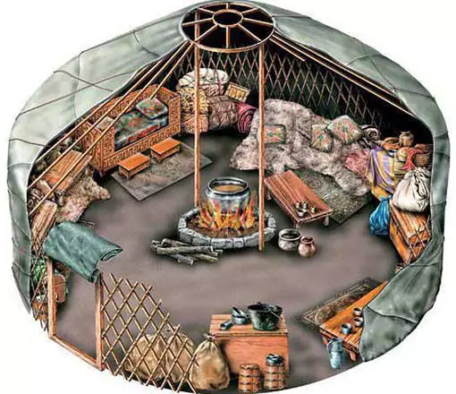

Many people see Genghis Khan as a great leader and a hero. He united the Mongol tribes and created an empire that brought trade and new ideas across Asia and Europe. Under his rule, the Silk Road, a famous trade route, became safer, allowing merchants to travel and share goods like silk, spices, and inventions. Unlike many rulers of his time, Genghis Khan promoted people based on their abilities instead of their family background or loyalty. This made his army and government stronger, as the most talented people got important jobs. He also encouraged religious freedom, allowing people of different faiths—such as Buddhists, Muslims, and Christians—to live peacefully in his empire. Some historians admire him for his leadership, intelligence, and ability to create a strong empire from many different cultures.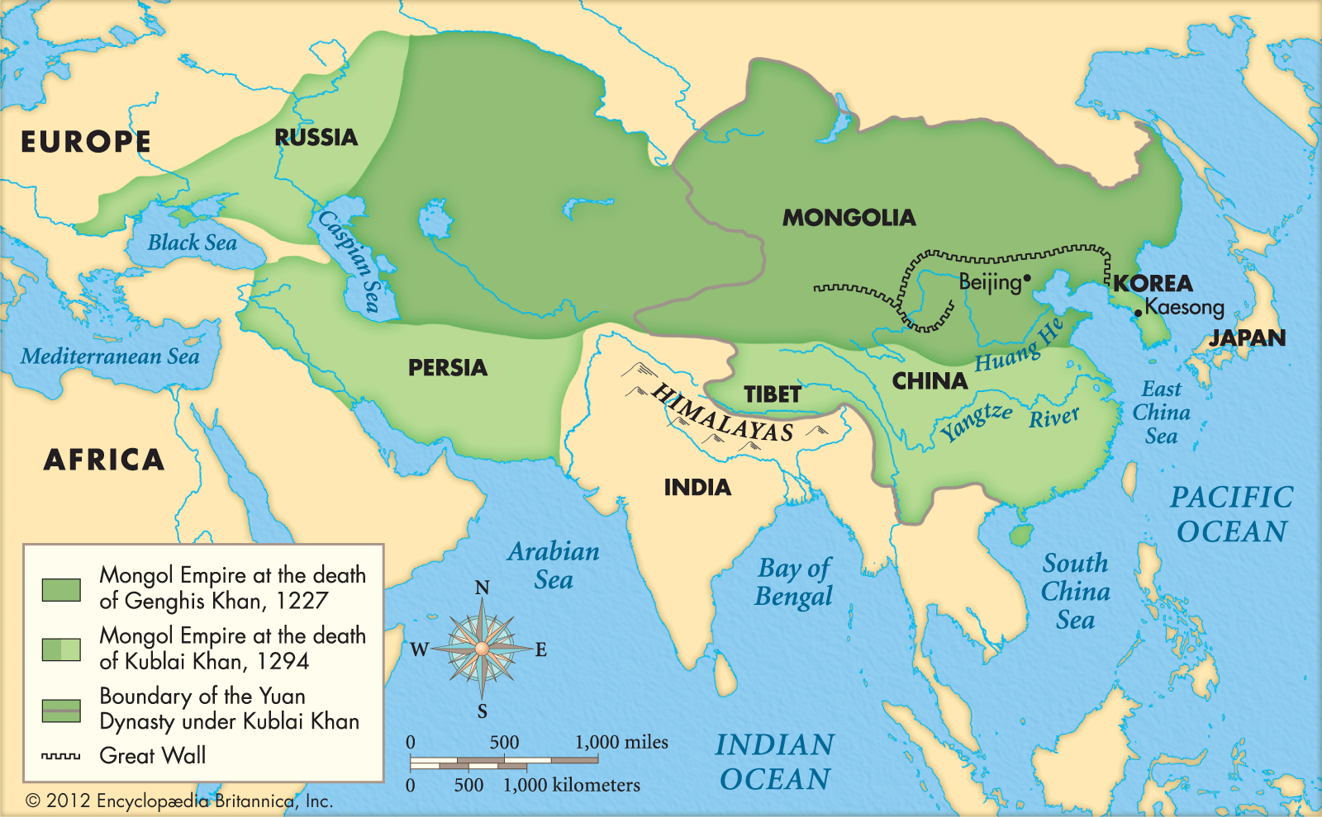

However, others see Genghis Khan as a villain because of the destruction he caused. His army was known for being ruthless, destroying entire cities, and killing millions of people. When the Mongols attacked a place, they often left nothing behind. One of the most tragic events was the destruction of Baghdad in 1258 by Mongol forces led by Genghis Khan’s grandson, Hulagu Khan. The Mongols burned the great libraries of Baghdad, which held thousands of books filled with knowledge about science, medicine, and history. Many scholars believe this was a huge loss to human civilization. The Mongols also used brutal tactics, such as forcing people to become human shields and wiping out entire populations. Because of this, Genghis Khan is remembered in very different ways—some as a hero, and others as a brutal warrior.