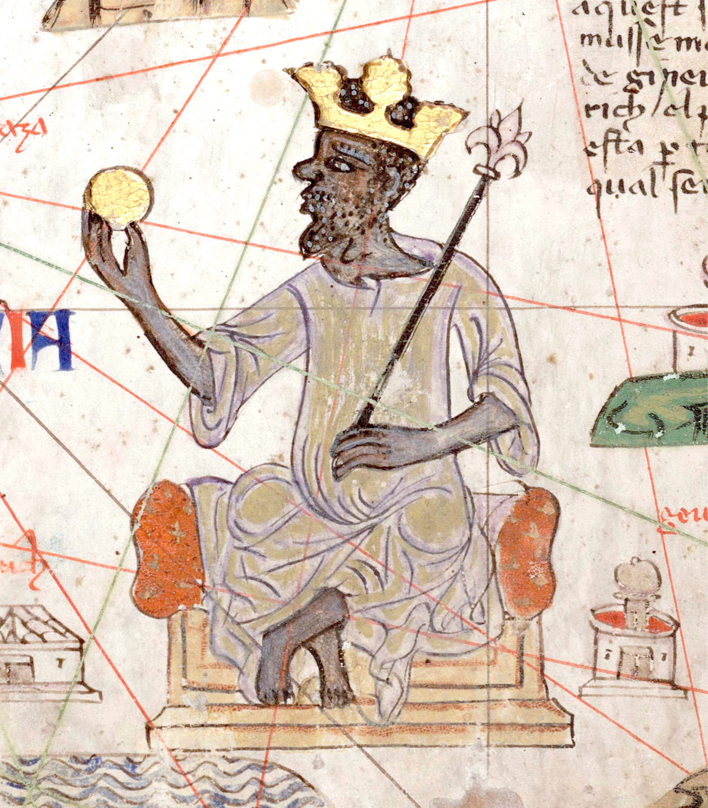
Mansa Musa: Richest Ruler in History
Mansa Musa was the king of the Mali Empire in West Africa during the 1300s. He is known as one of the richest people in history. His empire was full of gold, salt, and other valuable resources. Mansa Musa is most famous for his long journey to Mecca, called a pilgrimage. On the way, he gave out so much gold that it affected the economy in the places he visited. He also helped make Mali a center of learning and culture by building schools, libraries, and mosques.
Why Mansa Musa is a Hero
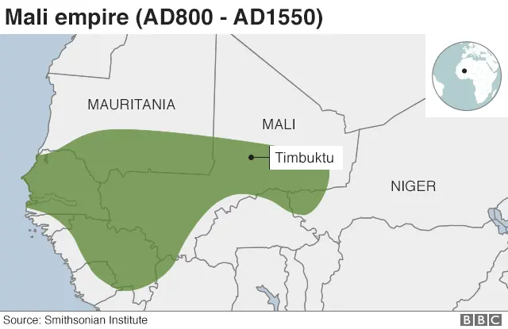
Many people see Mansa Musa as a hero because he used his power to grow and strengthen his empire. He helped spread education and Islam across West Africa. Mansa Musa brought architects and scholars from other countries to help build beautiful cities like Timbuktu. He made it easier for people to learn and trade. His generosity during his pilgrimage showed that he cared about helping others. People in Mali and beyond still remember him as a wise and generous leader.

Why Mansa Musa Could Be a Villain
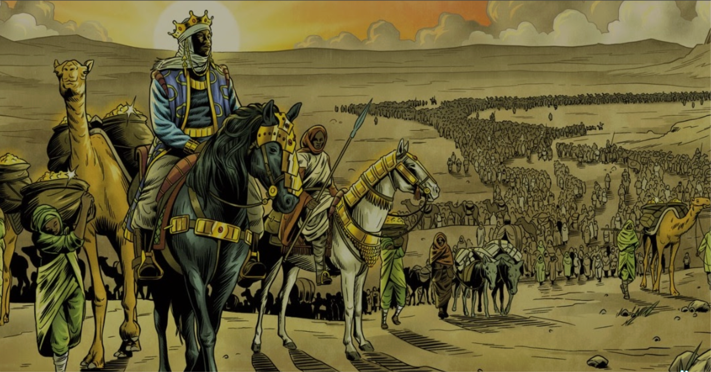
However, some people think Mansa Musa may not have been a perfect hero. He gave away so much gold on his trip that it caused problems in some cities. Prices went up, and the economy became unstable. Also, like many rulers at the time, he had power over many people, including slaves. The Mali Empire grew through war, and Mansa Musa may have taken land from others by force. Mansa Musa owned 12,000 slaves. Can a ruler be a hero with so many humans as property?
Vocabulary List
- Empire – a group of countries or areas ruled by one leader
- Pilgrimage – a journey to a holy place
- Economy – the system of money, goods, and jobs in a country
- Generosity – being kind and giving to others
- Architect – a person who designs buildings
- Scholar – someone who studies and learns a lot about one subject
- Trade – the exchange of goods and services
- Stable – strong and not likely to change or fall
- Slaves – people who are owned and forced to work without pay
Reading Comprehension Questions - Pick 3 questions. Answer with 2-3 full sentences per question.
- Who was Mansa Musa and when did he rule?
- What made Mansa Musa famous during his pilgrimage?
- What are two things Mansa Musa did to help his empire?
- Why do some people say he caused problems during his journey?
- How did the Mali Empire grow under Mansa Musa’s rule?
Discussion Questions - Start discussing any questions after two people have finished their answers above
- Do you think Mansa Musa was more of a hero or a villain? Why?
- Is it possible for someone to be both good and bad at the same time?
- If you were a ruler with great wealth, how would you use your power?
- What can we learn from Mansa Musa’s leadership today?

