| **MS Summative Assessment Task Sheet** |  |
| --- | --- |

| **Grade: 8**  **Unit Title: The Art of Manipulation Formative Due date: May 7 (AB) May 9 (CD)**  **Summative Due date: May 14 (AB) May 23 (CD)** | **Summative Assessment Title:**  **Art of Manipulation Argumentative Essay and Exhibition** |
| --- | --- |

| **Task Description and Relationship to Statement of Inquiry:** | |
| --- | --- |
| **Goal:** To explain how an authoritarian states used media, educational, and legal manipulation against its citizens to commit human rights abuses, or how people resisted an authoritarian state using legitimate forms of persuasion.  **Role:** You are a historian.  **Audience:** G8 students.  **Scenario:** You must help the modern generation understand what has gone in the past so we do not repeat the same mistakes in the future.  **Performance:** Argumentative Essay.  **Relationship to Statement of Inquiry:** In the summative assessment, students will explore how authoritarian states have used media, education, and legal systems to manipulate public perception and justify human rights abuses or how individuals and groups have resisted such regimes through legitimate persuasion. The statement of inquiry—"Form and composition can be used to manipulate an audience's sense of fairness and development"—directly relates to this investigation, as authoritarian governments carefully structure propaganda, curriculum, and laws to create an illusion of justice and progress while suppressing dissent. Conversely, resistance movements strategically craft persuasive arguments, protests, and counter-narratives to expose injustice and advocate for change. By analyzing historical examples, students, acting as historians, will demonstrate how these methods shaped public understanding, drawing lessons to ensure that such manipulation does not recur in the future.  **Instructions for students:** Teachers will support students during each lesson on how to write each paragraph. We will be spending one lesson per paragraph so that students can request help if they are unsure with the format. A sample essay has been included here which the teachers will go over for the students. Students may choose from the list below (where many sources are pre-prepared) or they can do a different case study after discussing with a teacher. You will first hand write your essay. Then you will type it up after a teacher has approved your draft. After you finish typing it up, you will create a digital exhibition where we will celebrate our learning at the end of the unit. This is a RED assignment which means no AI is to be used. | |

| **Criteria & Strands:** | |
| --- | --- |
|  | |

| **Options and Sources** | |
| --- | --- |
| **Communist Propaganda in Stalin’s Soviet Union (1927-1953)**  [Media 1,](https://comradekiev.com/blog/the-definitive-history-soviet-propaganda-poster/) [Media 2](https://www.youtube.com/watch?v=cYq38lFq0uU), [Media 3](https://www.youtube.com/watch?v=TgzrI1okwrQ)  [Education 1](https://rarehistoricalphotos.com/stalin-photo-manipulation-1922-1953/), [Education 2](https://coldwar.unc.edu/2022/12/the-korean-war-1972/)  [Laws](https://www.britannica.com/event/Great-Purge)  **Communist Propaganda in Mao’s China (1949-1976)**  [Media 1](https://www.theguardian.com/artanddesign/gallery/2012/mar/07/chinese-propaganda-posters-in-pictures), [Media 2](https://blog.bridgemanimages.com/blog/controlling-the-state-chinese-propaganda-posters), [Media 3](https://www.youtube.com/watch?v=liMlM4rhkkA)  [Education 1](https://www.bbc.com/news/magazine-34932800), [Education 2](https://ischool.uw.edu/podcasts/dtctw/maos-little-red-book)  [Laws](https://www.theguardian.com/world/2016/may/11/the-cultural-revolution-50-years-on-all-you-need-to-know-about-chinas-political-convulsion)  **Communist Propaganda in Pol Pot’s Cambodia (1975-1979)**  [Media 1](https://www.ushmm.org/genocide-prevention/countries/cambodia/case-study/background/origins-of-the-khmer-rouge), [Media 2](https://www.youtube.com/watch?v=hJ5audkrXKY)  [Education](https://worldschildrensprize.org/roomtoreadincambodia)  [Laws](https://www.britannica.com/event/Cambodian-Genocide)  **Communist Propaganda in Castro’s Cuba (1959-2008)**  [Media](https://www.theguardian.com/world/2016/nov/27/fidel-castro-personality-cult-propaganda-power)  [Education](https://diariodecuba.com/cuba/1580140471_8971.html)  [Laws](https://www.hrw.org/news/2016/11/26/cuba-fidel-castros-record-repression)  **Communist Propaganda in the Mengistu’s Ethiopia (1974-1991)**  [Media](https://www.youtube.com/watch?v=4rhtcxL6z0Q)  [Education 1](https://addisfortune.net/columns/commie-monuments-two-faces/), [Education 2](https://www.youtube.com/watch?v=mhASu0GsZVs)  [Laws](https://www.dw.com/en/quest-to-extradite-ethiopias-dictator-mengistu-as-mugabe-departs/a-41719005)  **Racism against African-Americans in the United States (19th to 20th century)**  [Media](https://www.americanheritage.com/blackface-sad-history-minstrel-shows)  [Education](https://birminghamwatch.org/racist-textbooks-endured-presenting-alternate-history-alabama-students-70-years/)  [Laws](https://www.pbs.org/wgbh/americanexperience/features/freedom-riders-jim-crow-laws/)  **Racism against Native-Americans in the United States (19th to 20th century)**  [Media](https://americanarchive.org/exhibits/native-narratives/misrepresentations)  [Education 1](https://www.theindigenousfoundation.org/articles/us-residential-schools), [Education 2](https://www.youtube.com/watch?v=UGqWRyBCHhw)  [Laws 1](https://www.loc.gov/classroom-materials/immigration/native-american/19th-century-perceptions/), [Laws 2](https://www.youtube.com/watch?v=dHENnP11HC0), [Laws 3](https://networkadvocates.org/recommittoracialjustice/legacy/)  **Racism against Chinese-Americans in the United States (19th to 20th century)**  [Media](https://www.today.com/popculture/here-s-how-pop-culture-has-perpetuated-harmful-stereotypes-asian-t213676)  [Education](https://time.com/5949028/asian-american-history-schools/)  [Laws 1](https://www.pbs.org/newshour/nation/the-long-history-of-racism-against-asian-americans-in-the-u-s), [Laws 2](https://news.harvard.edu/gazette/story/2021/03/a-long-history-of-bigotry-against-asian-americans/), [Laws 3](https://www.youtube.com/watch?v=yJI5veSM13Y), [Laws 4](https://www.youtube.com/watch?v=MsKXwstSScg)  **Racism against Jewish people in Iran (1979-present)**  [Media](https://www.adl.org/resources/blog/tehran-spreads-more-anti-semitism-military-tensions-increase)  [Education 1](https://www.ushmm.org/antisemitism/holocaust-denial-and-distortion/holocaust-denial-antisemitism-iran/2016-holocaust-cartoon-contests-in-iran/timeline), [Education 2](https://www.youtube.com/watch?v=mlWN7UTWw2Q)  [Laws](https://www.jewishvirtuallibrary.org/jews-of-iran)  **Racism against Tutsi people in Rwanda (1962-1994)**  [Media 1,](https://www.newtimes.co.rw/article/104771/National/dehumanisation-how-tutsis-were-reduced-to-cockroaches-snakes-to-be-killed) [Media 2](http://www.hscentre.org/sub-saharan-africa/media-tool-war-propaganda-rwandan-genocide/)  [Education](https://laviedesidees.fr/The-devils-from-the-Thousand-Hills.html)  [Laws 1](https://www.un.org/en/preventgenocide/rwanda/historical-background.shtml), [Laws 2](https://www.pbs.org/wgbh/pages/frontline/shows/rwanda/etc/cron.html), [Laws 3](https://www.youtube.com/watch?v=2iGxre5G3_k), [Laws 4](https://www.youtube.com/watch?v=5V82i_dpKos)  **Sexism in Afghanistan (1996-2001, 2021-present)**  [Media](https://www.opindia.com/2021/08/afghanistan-taliban-deface-beauty-parlour-burqa-sales-increase/)  [Education](https://www.bbc.com/news/world-asia-64045497)  [Laws 1](https://www.amnesty.org.uk/womens-rights-afghanistan-history), [Laws 2](https://www.hrw.org/news/2021/08/05/afghanistan-justice-system-failing-women), [Laws 3](https://www.youtube.com/watch?v=4vFgD4BWsv4)  **Sexism in Britain (19th to 20th century)**  [Media 1](https://mashable.com/feature/anti-suffrage-propaganda), [Media 2](https://www.nps.gov/articles/000/teaching-justice-anti-suffrage-postcards.htm)  [Education](https://www.bl.uk/romantics-and-victorians/articles/gender-ro)  [Laws 1](https://www.historylearningsite.co.uk/the-role-of-british-women-in-the-twentieth-century/women-in-1900/), [Laws 2](https://www.striking-women.org/module/women-and-work/19th-and-early-20th-century), [Laws 3](https://www.youtube.com/watch?v=8D_ubzQHWFI), [Laws 4](https://www.youtube.com/watch?v=ZNeg2cfUHRw) **Sexism in Iran (1979-present)** [Media 1](https://borgenproject.org/womens-rights-in-iran/) [Media 2](https://www.cbc.ca/radio/ideas/iran-women-protests-1979-revolution-1.6605982) [Media 3](https://www.bbc.com/news/world-middle-east-47032829) [Education](https://www.youtube.com/watch?v=WIv3dLiB0h8) Laws **Sexism in Saudi Arabia (1957-present)** [Media](https://www.arabnews.com/node/2075241/media) [Education](https://www.mei.edu/publications/education-key-womens-empowerment-saudi-arabia) [Laws 1](https://www.hrw.org/news/2019/01/30/saudi-arabia-10-reasons-why-women-flee) [Laws 2](https://www.amnesty.org/en/latest/research/2022/12/saudi-arabia-codifies-male-guardianship-and-gender-discrimination/) [Laws 3](https://www.emro.who.int/emhj-volume-16-2010/volume-16-issue-1/article19.html) [Laws 4](https://www.youtube.com/watch?v=-hIzuKAgrsU) **Sexism in Imperial China (various dynasties)** [Media 1](https://www.shine.cn/feature/art-culture/1906217077/) [Media 2](https://asianartnewspaper.com/captive-beauties/) [Education](http://www.csstoday.com/Item/8588.aspx) [Laws 1](https://www.worldhistory.org/article/1136/women-in-ancient-china/) [Laws 2](https://medium.com/history-uncut/challenging-gender-roles-in-han-dynasty-china-104c9b306e47) [Laws 3](https://www.youtube.com/watch?v=QBFmZl9kf9I) [Laws 4](https://www.youtube.com/watch?v=RlCtb_7zGeg) **Imperialist Propaganda in the British Empire (18th to 20th century)** [Media 1](https://contestedrepresentations.history.lmu.build/group-3/timothy-v/) [Media 2](https://allthatsinteresting.com/british-colonial-films) [Media 3](https://www.iwm.org.uk/learning/resources/first-world-war-recruitment-posters) [Education](https://www.history.com/topics/early-20th-century-us/social-darwinism) [Laws 1](https://unherd.com/2021/05/how-racist-was-the-british-empire/) [Laws 2](https://www.theguardian.com/commentisfree/2020/jun/24/britain-persistent-racism-imperial-history) **Imperialist Propaganda in the Japanese Empire (19th to 20th century)** [Media 1](https://news.library.sydney.edu.au/greater-east-asia-exhibition/) [Media 2](https://fanningtheflames.hoover.org/engage#propaganda) [Media 3](https://www.youtube.com/watch?v=ftg22GSSjsA) [Media 4](https://www.youtube.com/watch?v=MHp98DP6qsA) [Media 5](https://www.youtube.com/watch?v=wbdhs_ND-KI) [Education 1](https://www.enemyinmirror.com/education-imperial-japan/) [Education 2](https://www.k12academics.com/Education%20Worldwide/Education%20in%20Japan/History%20of%20Education%20in%20Japan/education-empire-japan) [Laws 1](https://www.history.com/news/comfort-women-japan-military-brothels-korea) [Laws 2](https://www.npr.org/sections/goatsandsoda/2020/12/04/940819094/photos-there-still-is-no-comfort-for-the-comfort-women-of-the-philippines) **Imperialist Propaganda in the Russian Empire (17th to 20th century)** [Media 1](https://www.rferl.org/a/russias-world-war-one-propaganda-posters/29292228.html) [Media 2](https://sites.utexas.edu/ransomcentermagazine/2014/03/04/posters-portray-food-as-evil/) [Media 3](https://encyclopedia.1914-1918-online.net/article/propaganda_at_home_russian_empire) [Education](https://tsarnicholas.org/2020/07/08/russias-national-educational-project-of-emperor-nicholas-ii/) [Laws](https://www.bbc.co.uk/bitesize/guides/z9qnsbk/revision/3) **Imperialist Propaganda in the French Empire (18th to 20th century)** [Media 1](https://www.stairsainty.com/2016/11/21/art-propaganda-restoration-louis-philippe/) [Media 2](https://www.agefotostock.com/age/en/Stock-Images/french-propaganda-postcard.html) [Media 3](https://www.thecollector.com/napoleon-bonaparte-portraits-propaganda-art/) [Media 4](https://www.alamy.com/stock-photo/french-colonialism.html?sortBy=relevant) [Media 5](https://www.ngv.vic.gov.au/napoleon/art-and-design/propaganda.html) [Media 6](https://www.youtube.com/watch?v=KvJf86wIov8) [Media 7](https://www.youtube.com/watch?v=w2OTUmLupdw) [Education](https://www.theguardian.com/world/2005/apr/15/highereducation.artsandhumanities) [Laws](https://www.cam.ac.uk/research/features/before-race-mattered-what-archives-tell-us-about-early-encounters-in-the-french-colonies) **Imperialist Propaganda in the Spanish Empire (15th to 19th century)** [Media](https://www.khanacademy.org/humanities/art-americas/new-spain/viceroyalty-new-spain/a/hispaniolas-early-colonial-art-introduction) [Education](https://intotherose-garden.com/2013/12/10/catholic-evangelism-spanish-colonialism/) [Laws 1](https://www.worldhistory.org/Spanish_Requirement/) [Laws 2](https://www.youtube.com/watch?v=zmcKS47BsAo) **Ableism against people with disabilities in Britain (19th to 20th century)** [Media](https://www.english-heritage.org.uk/visit/blue-plaques/blue-plaque-stories/eugenics/) [Education](https://historicengland.org.uk/research/inclusive-heritage/disability-history/1914-1945/) [Laws 1](https://disability-studies.leeds.ac.uk/wp-content/uploads/sites/40/library/Barnes-disabled-people-and-discrim-ch2.pdf) [Laws 2](https://www.youtube.com/watch?v=39QRBowHOQ8) **Ableism against people with disabilities in the United States (19th to 20th century)** [Media 1](https://www.aruma.com.au/about-us/blog/run-forest-run-disability-stereotypes-in-the-media/) [Media 2](https://nbcuacademy.com/disabilities-media/) [Education 1](https://sites.ed.gov/idea/) [Education 2](https://www.ada.gov/) [Laws](https://knightpoliticalreporting.syr.edu/?civilhistoryessays=a-civil-rights-history-americans-with-)  **Ableism against people with disabilities in Nazi Germany (1933-1945)**  [Media 1](https://www.youtube.com/watch?v=x81o-NB3kmE), [Media 2](https://www.hmd.org.uk/learn-about-the-holocaust-and-genocides/nazi-persecution/disabled-people/)  [Education](https://www.ushmm.org/collections/bibliography/nazi-racial-science)  [Laws 1](https://www.ushmm.org/information/exhibitions/online-exhibitions/special-focus/nazi-persecution-of-the-disabled), [Laws 2](https://www.jewishvirtuallibrary.org/nazi-persecution-of-the-mentally-and-physically-disabled)  **Ableism against people with albinism in Tanzania (20th century)** [Media](https://www.voaafrica.com/a/protect-albinos-tanzania---rights-groups/6823967.html) [Education](https://www.hrw.org/news/2019/02/09/it-felt-punishment-growing-albinism-tanzania) [Laws 1,](https://www.bbc.com/news/world-africa-30394260) [Laws 2,](https://www.ohchr.org/en/stories/2014/12/protect-rights-people-albinism) [Laws 3](https://www.researchgate.net/publication/335440203_Human_rights_violations_of_persons_with_albinism_in_Tanzania_The_case_of_children_in_temporary_holding_shelters)  **Ableism against people with albinism in Zimbabwe (20th century)**  [Media](https://qz.com/africa/1108737/we-are-no-different-a-touching-ad-campaign-in-zimbabwe-captures-life-with-albinism)  [Education](https://zimalbino.co.zw/)  [Laws 1,](https://apnews.com/article/death-of-george-floyd-zimbabwe-virus-outbreak-ap-top-news-international-news-7eae9a42465074ff4b3eb20399991251) [Laws 2](https://beyondsuncare.org/en/persecucion/) | |

| **Essay Sentence Stems** | |
| --- | --- |
| **1. Come up with a preliminary thesis.** A thesis summarises the entire argument of your essay in one sentence. You can change your thesis if you think it is necessary over time. This is the sample thesis from the sample essay in your rubric:  *The thesis of this essay is that Nazi Germany’s use of media, education, and laws to manipulate its people was a major factor that contributed to the murder of six million Jews in the Holocaust during the Second World War.*  2. Read one of your media/education/law sources as provided for you (check student portal).  3. For Diii, create an OPVL for one of the primary sources used in your media/education/law source.  4. For Div, explain which logical fallacy the primary source is committing.  5. For Dii, relate your paragraph back to the thesis.  **How to write an OPVL for each paragraph for Diii:**  Origin:  An example of manipulation via ___ (media, education, or law) is the source “___” (name of source).  The origin of this ___ (primary or secondary) source was made in ___ (year) by ___ (person or government who made this source).  Purpose:  The purpose of this source was to clearly convince ___ that they should ___.  This was done by ___ as demonstrated in the pictures below.  Value:  The value of this source is that it clearly demonstrates the opinion of ___ and is evidence for historians who want to understand why ___.  Limitations:  The limitations of this source are that it is completely biased in favour of ___ and against ___.  **How to input a logical fallacy in each paragraph for Div:**  The argument presented in the source commits the “___” logical fallacy because ___ when in reality___.  **How to relate each paragraph to the thesis for Dii:**  This source relates to the thesis because ___.  **How to write an introduction and conclusion paragraph for Di:**  Introduction (first paragraph):  ___ (Use two sentences to explain the background of the regime responsible for the propaganda).  The thesis of this essay is ___ (Bold your thesis and summarise your argument in one sentence. It should be an answer to your research question).  This essay will use the ____ (first source), as an example of manipulation via media, ___ (second source) as an example of manipulation via education, and ___ (third source) as an example of manipulation via law.  Introduction (second paragraph):  ___ (provide 3-4 sentences that provide context of the who regime was/is and their ideology).  Conclusion (final paragraph):  ___ (provide 3-4 sentences that summarise your argument and any important lessons for us today) | |

| **Criteria Bi: Research Question** | | | | | |
| --- | --- | --- | --- | --- | --- |
| My research question is:  This question is important because: | | | | | |
| **Criteria Bii: Action Plan** | | | | | |
| Date: | | Objective: | | To what extent did you achieve your objective?: | |
|  | |  | |  | |
|  | |  | |  | |
|  | |  | |  | |
|  | |  | |  | |
|  | |  | |  | |
|  | |  | |  | |
|  | |  | |  | |
|  | |  | |  | |
|  | |  | |  | |

| **Criteria Biv: Reflection** | |
| --- | --- |
| How would you grade yourself on each strand and why?  Bi:  Bii:  Biii:  Biv:  Di:  Dii:  Diii:  Div:  What did you do well during this unit?  What could you have improved upon this unit?  Which ATL skill do you believe you developed the most and why?  To what extent did you enjoy this unit? How would you rate it out of 10?  (10=Fantastic, 5=Alright, 1=Poor).  Is there anything about this unit that you would want changed to improve your learning experiences? | |

Amina Lee

Ms. Smith

Individuals and Societies

22 May 2023

Essay: Anti-Semitism in Nazi Germany

Anti-Semitism is a form of racism that targets Jewish people. Although the discrimination and mass killings of Jewish people can be traced back to at least over the past two thousand years, the largest genocide committed against Jewish people was conducted by Adolf Hitler in Nazi Germany between 1933-1945. **The thesis of this essay is that Nazi Germany’s use of media, education, and laws to manipulate its people was a major factor that contributed to the murder of six million Jews in the Holocaust during the Second World War.** Although it is true that the Nazi regime was an absolute dictatorship that forced Hitler’s ideology onto its citizens, the sheer scale of the Holocaust could not have been undertaken without a significant quantity of people who were genuinely convinced and manipulated by Nazi propaganda. This essay will use the 1940 film “The Eternal Jew” as an example of manipulation via media, the 1938 book “The Poisonous Mushroom” as an example of manipulation via education, and the 1935 “Nuremberg Laws” as an example of manipulation via law (The Holocaust Year by Year).

When the Nazis came to power in Germany in 1933, they did not begin to immediately deport Jewish people into concentration camps to be gassed. Although many Germans already held antisemitic beliefs, there were not enough Germans, for Hitler’s liking, who enthusiastically wanting to exterminate the Jewish people. Although state-sponsored violence against Jewish people slowly increased between 1933-1941, the mass murder of millions took place between 1941-1945. Therefore, between 1933-1941, the Nazis used media, education, and laws to manipulate and brainwash the population into supporting the Holocaust (The Holocaust Year by Year).

An example of media manipulation is the film “The Eternal Jew”. The origin of this primary source was made in 1940 by Fritz Hippler under the orders of Joseph Goebbels, both of whom ran the Ministry of Propaganda. The purpose of this propaganda was to clearly convince Germans that Jewish people were “parasites” that needed to be eliminated. This was done by comparing Jewish people to rats as shown in the two screenshots below. The value of this source is that it clearly demonstrates the opinion of the Nazi German regime against Jewish people and is evidence for historians who want to understand why the Nazis were antisemitic. This film is consistent with other Nazi posters that characterise Jewish people in the shape of rats. The limitations of this film are that it is completely biased in favour of the Nazis and against the Jews and has no factual accuracy whatsoever. Some people who have had no education about Nazi Germany or Jewish people, or are antisemitic themselves, may actually believe what is said in this film. The argument presented in the film commits the “appealing to emotion” logical fallacy because it attempts to scare the viewer by using rats which is an animal that many people are afraid of, rather than using facts and context to back up its arguments. This source relates to the thesis because many people were manipulated and supported Nazi Germany’s antisemitic policies because they became genuinely afraid of Jewish people due to their association with rats and perceived Jewish people as a “legitimate” threat (Der Ewige Jude).

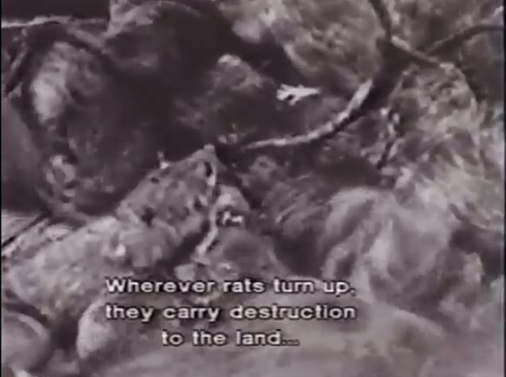 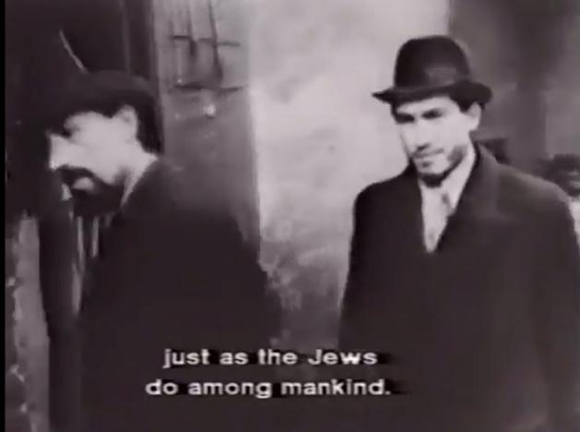

An example of educational manipulation is the book “The Poisonous Mushroom”. The origin of this primary source was made in 1938 by Nazi Party Member Julius Streicher. The purpose of this propaganda was to clearly convince German children that they should be afraid of Jewish people the same way that they would be afraid of poisonous mushrooms. This was done by showing negative stereotypes of Jewish physical features such as the “hooked nose” as demonstrated in the pictures below. The value of this source is that it clearly demonstrates the opinion of the Nazi German regime against Jewish people and is evidence for historians who want to understand why the Nazis were antisemitic. This book is consistent with other Nazi posters that characterise Jewish people with threatening auras and hooked noses. The limitations of this book are that it is completely biased in favour of the Nazis and against the Jews and has no factual accuracy whatsoever. Some people who have had no education about Nazi Germany or Jewish people, or are antisemitic themselves, may actually believe what is written in this book. The argument presented in the book commits the “strawman” logical fallacy because it builds an argument against a false negative stereotype of Jewish people instead of the reality where there is a huge diversity of physical appearances of Jewish people from all over the world. This source relates to the thesis because many people were manipulated and supported Nazi Germany’s antisemitic policies because they were taught these beliefs as “facts” in school as children when they were easily impressionable (Antisemitic Children's Book).

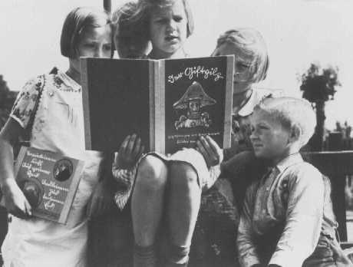 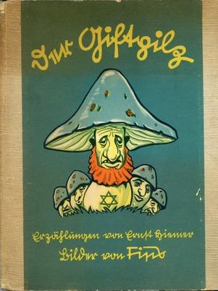 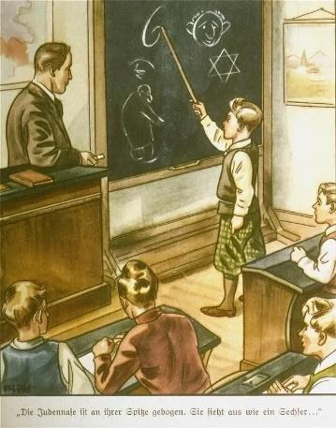

An example of manipulation via law are the “Nuremberg Laws”. The origin of this primary source was made in 1935 when it was passed in the Nazi German Reichstag. The purpose of these laws was to take away the citizenship of any German who had Jewish ancestry. This was done by tracing people’s family tree to identify if they “qualified as Jewish” as demonstrated in the pictures below. The value of this source is that it clearly demonstrates the opinion of the Nazi German regime against Jewish people and is evidence for historians who want to understand how the Nazis codified their beliefs into law. These laws are consistent with other Nazi laws that would become more severe as deadly over time. The limitations of these laws as a source are that they do not reveal the subsequent laws that would later lead to the physical elimination of the Jews during the Holocaust. The argument presented in these laws commits the “composition/division” logical fallacy because it assumes that one member in your family tree would automatically make you Jewish and ignores the person’s connection to the Jewish faith, culture, and personal relationship with Jewish family members. This source relates to the thesis because many people were manipulated and supported Nazi Germany’s antisemitic policies because between 1935-1945 Jewish people were no longer citizens of Germany and therefore could more easily be identified as a “foreign enemy” (Chart Illustrating Nuremberg Laws).

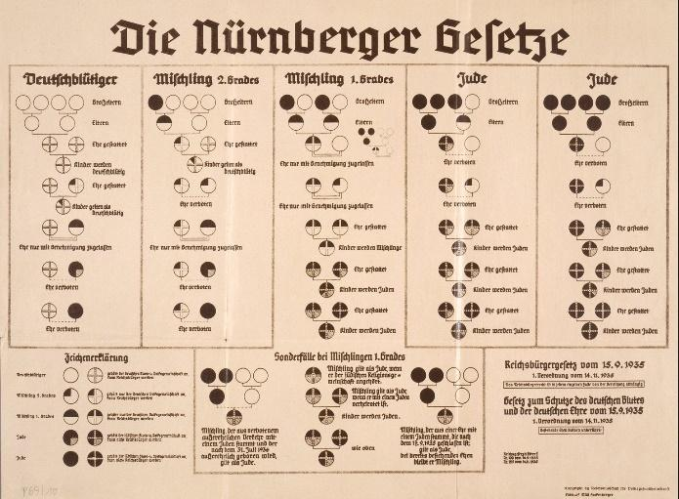 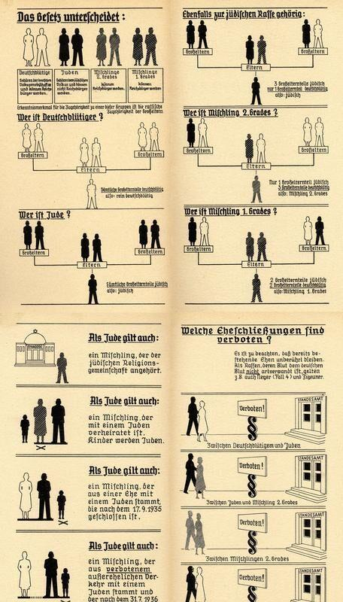

In conclusion, Nazi media, education, and laws were crucial pre-requisites for the Holocaust. Without scaring the Germans, manipulating Germans as children, and disenfranchising German-Jews, the Holocaust could not have killed as many as it did. This should serve as a warning to how we can be manipulated, regardless of our age, into believing hateful ideologies that ultimately lead to genocide. It takes more than weapons to kill people, it also takes a manipulative ideology.

Works Cited

“Antisemitic Children's Book.” *Facing History and Ourselves*, <https://www.facinghistory.org/resource-library/antisemitic-childrens-book>.

“Chart Illustrating Nuremberg Laws.” *Facing History and Ourselves*, <https://www.facinghistory.org/resource-library/chart-illustrating-nuremberg-laws>.

“Der Ewige Jude.” *United States Holocaust Memorial Museum*, United States Holocaust Memorial Museum, <https://encyclopedia.ushmm.org/content/en/article/der-ewige-jude>.

“The Holocaust Year by Year.” *BBC Teach*, BBC, 30 Jan. 2020, <https://www.bbc.co.uk/teach/the-holocaust-year-by-year/zkxwgwx>.