**Grade 8: Individuals and Societies**

Unit 4 Syllabus: The Art of Manipulation

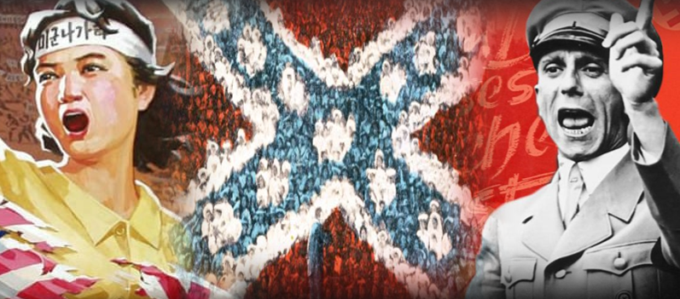

Students will explore the ways in which authoritarian and human rights-abusing states manipulated societies and eliminated critical thinking. We will study Nazi Germany, Apartheid South Africa, the Confederate States, and North Korea before allowing students to investigate an authoritarian government through the lens of manipulation or from those fighting authoritarian governments through the lens of legitimate persuasion. We will be exploring these topics through the following questions and concepts:

**Factual question**:

What are some ways people can manipulate an audience's view on democracy, politics, government, and civil society?

**Conceptual question**:

How do choices of form and logic politically influence an audience?

**Debatable**:

What is the most effective form of political manipulation?

**Statement of Inquiry:**

Form (Key Concept) and composition (Related Concept) can be used to manipulate an audience's sense of fairness and development (Global Context).

**Assessment:**

Students will write a six-paragraph essay about how media, education, and laws manipulated individuals and societies about a particular subject of choice. Students will be assessed on Criteria B (Investigating) and Criteria D (Thinking Critically). The Task Sheet and Rubric is available on Toddle.

| **Unit Calendar** | | |
| --- | --- | --- |
| Date | Lesson | Theme |
| **AB: Wed 19 Mar**  CD: Thu 20 Mar*  CD: Fri 21 Mar*  **CD: Mon 24 Mar** | L1: Introduction to Concepts  *CD Grow Time | Introduction |
| AB: Thu 20 Mar  CD: Thu 27 Mar | L2: Nazi Media | Manipulation through Media |
| AB: Mon 24 Mar  CD: Fri 28 Mar | L3: Confederate, Apartheid, & North Korean Media |
| AB: Wed 26 Mar  CD: Thu 3 Apr | L4: Read Sample Essay, Pick Topic, & Action Plan |
| AB: Thu 27 Mar  CD: Fri 4 Apr | L5:Media Manipulation Body Paragraph |
| AB: Wed 2 Apr  Mon: Mon 7 Apr | L6: Nazi & North Korean Education | Manipulation through Education |
| AB: Thu 3 Apr  CD: Thu 10 Apr* | L7: Confederate & Apartheid Education  *ISSEA |
| AB: Mon 7 Apr  CD: Fri 11 Apr* | L8: Education Manipulation Body Paragraph  *ISSEA |
| AB: Wed 9 Apr*  CD: Mon 14 Apr | L9: North Korean Laws  *ISSEA | Manipulation through Laws |
| AB: Thu 10 Apr*  CD: Thu 17 Apr | L10: Apartheid Laws  *ISSEA & Parade |
| AB: Mon 14 Apr*  AB: Wed 16 Apr*  AB: Thu 17 Apr*  **AB: Wed 23 Apr\*\***  **CD: Thu 24 Apr** | L11:**Confederate Laws  *AB Grow Time  **Open House |
| AB: Thu 24 Apr  CD: Fri 25 Apr* | L12: Nazi Laws  *Law Manipulation Body Paragraph |
| AB: Mon 28 Apr*  **AB: Wed 30 Apr**  **CD: Mon 28 Apr\*\*** | L13: Law Manipulation Body Paragraph  *PYPx  **Introduction and Conclusion Paragraphs |
| AB: Wed 7 May  CD: Thu 8 May* | L14: Introduction and Conclusion Paragraphs  *Nazi Laws | Conclusion |
| AB: Thu 8 May**  **AB: Mon 12 May**  **CD: Fri 9 May** | L15: Type Essay  **MAP Test |
| **AB: Wed 14 May**  CD: Mon 12 May*  CD: Thu 15 May*  CD: Fri 16 May*  **CD: Mon 19 May** | L16: Respond to Formative Feedback  *CD Grow Time |
|
|
| AB: Thu 15 May  CD: Thu 22 May | L17: Prepare Digital Exhibition |
| AB: Mon 19 May  CD: Fri 23 May | L18: Digital Exhibition and Reflection |
| AB: Wed 21 May  AB: Thu 22 May  AB: Mon 26 May  CD: Mon 26 May | L19: Hidden Figures Film & Nat Geo Documentary |