MS Summative Assessment Task Sheet | 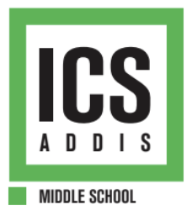

Grade: 7  Unit Title: The Tragedy of Diplomacy  Formative Due date: Apr 30 (AB) Apr 29 (CD)  Summative Due date: May 16 (AB) May 23 (CD) | Summative Assessment Title:  The Tragedy of Diplomacy Debate

Task Description and Relationship to Statement of Inquiry:
Goal: To argue that either peace or diplomacy is the fastest way to solve an on-going conflict.
Role: You are a lawyer in the International Court of Justice
Audience: G7 students.
Scenario: You will be assigned to a team to argue whether or not war or diplomacy should be used to solve the conflict either between Ukraine and Russia, the Democratic Republic of Congo and Rwanda, or Venezuela and Guyana.
Performance: Debate.
Relationship to Statement of Inquiry: The statement of inquiry, "The power to facilitate war and peace is influenced by boundaries that enforce global interactions," connects directly to the summative debate task by encouraging students to explore how political, geographical, and ideological boundaries shape the decisions nations make in conflict situations. Through the simulation of the International Court of Justice, students critically examine how states justify war or diplomacy, reflecting on the global implications of these choices. The debates require students to consider how international laws, national interests, and territorial boundaries influence whether a country pursues peace or engages in conflict, aligning with the inquiry’s focus on the forces that guide global interactions and outcomes.
Instructions for students: There will be three debates. You will take a survey to choose which debate and which side you want to be on. These debates will simulate the ‘International Court of Justice’. This official United Nations court deals with disputes between UN Member States. Although you will be put into teams, all grades will be individual. Please see the rubric at the bottom to understand how you will be graded. There is a template for you to use Below you will find a summary of each argument and resources to learn more. We will support you during each lesson how to formulate your arguments, prepare for rebuttals, and how to properly follow a debate procedure.
During each debate, one country will advocate in favour of war to solve the conflict and the other will advocate diplomacy to solve the conflict. Please keep in mind that in every country there are a variety of opinions of how to solve conflicts that include both war and diplomacy. In order to organize this summative, one side will be advocating for one method. This does not mean that 100% of all people in that country support this method.

Criteria & Strands:
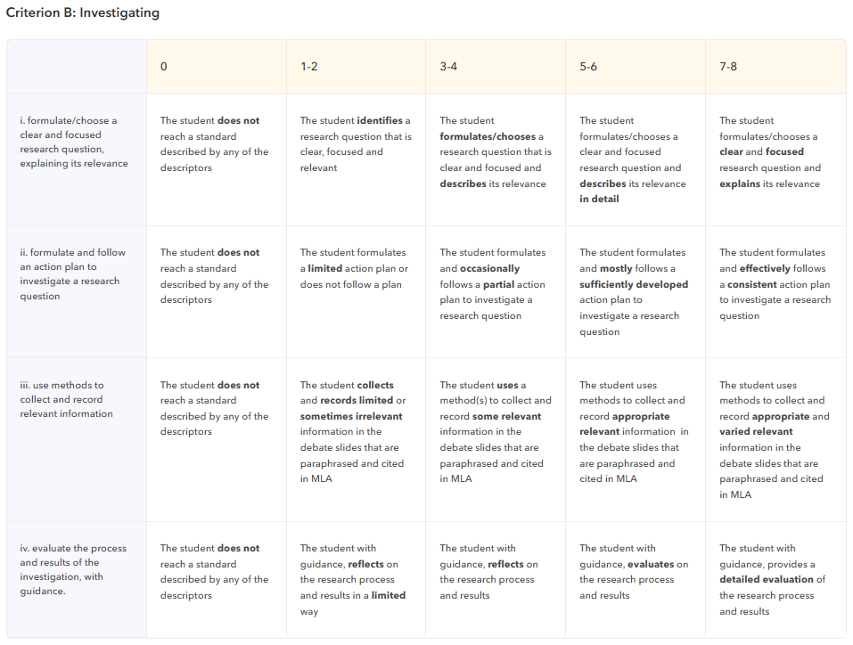
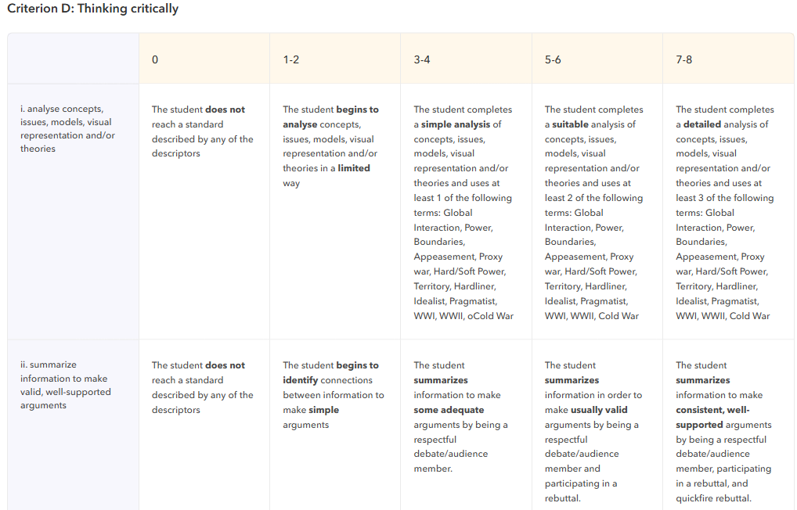
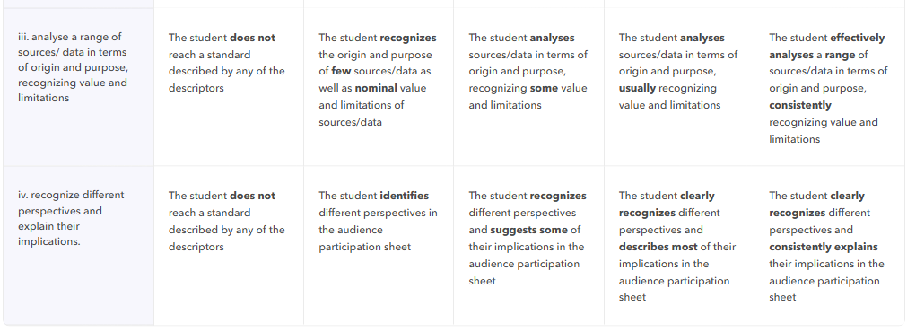

Option 1A:  Ukraine | Thesis:  “War is the best way to solve the conflict between Ukraine and Russia”.
Summary of Main Arguments:
1. Russia only wants diplomacy because they want to keep control of Ukrainian land. Appeasing Russia will only delay a future war.
2. Russia promised to respect Ukraine’s territorial sovereignty in exchange for Ukraine giving up its nuclear weapons in the 1994 Budapest Memorandum. Russia broke this promise which means any diplomatic agreements with Russia in the future will probably be broken.
3. Russia started this war and should suffer the consequences through war. Not fighting back will show weakness. Putin only understands strength.
Option 1B:  Russia | Thesis:  “Diplomacy is the best way to solve the conflict between Ukraine and Russia”.
Summary of Main Arguments:
1. This war has killed so many people, we should try to use diplomacy to prevent future deaths.
2. If Ukraine promises not to join NATO or the European Union, then this war can end.
3. If Ukraine does not discriminate against ethnic Russians, then this war can end.
Resources for Main Arguments and OPVLs:
Video 1, Video 2, Video 3, Video 4

Option 2A:  Rwanda | Thesis:  “War is the best way to solve the conflict between Rwanda and Congo”.
Summary of Main Arguments:
1. War is needed to support M23 so that they protect the Tutsis from being attacked by the same people who murdered Tutsis during the Rwandan Genocide.
2. War is needed to support M23 so that they protect the Tutsis from being attacked by ISIS terrorists.
3. Eastern DRC is so chaotic that Tutsis need to be supported with soldiers.
Option 2B:  Congo | Thesis:  “Diplomacy is the best way to solve the conflict between Rwanda and Congo”.
Summary of Main Arguments:
1. M23 is supplied by Rwanda. If Rwanda simply stopped arming them, then there could be peace.
2. The US supplies Rwanda with weapons. If the US stops arming Rwanda, then there could be peace.
3. Rwanda only uses war in eastern Congo to gain access to minerals, it has nothing to do with discrimination against Tutsis.
Resources for Main Arguments and OPVLs:
Video 1, Video 2, Video 3, Video 4

Option 3A:  Venezuela | Thesis:  “War is the best way to solve the conflict between Venezuela and Guyana”.
Summary of Main Arguments:
1. Western Guyana should belong to Venezuela because it was the British Empire that drew these borders unfairly using violence. Violence should be used to correct this British mistake.
2. Almost no people live in Western Guyana, so if there is a war, there will be very few civilian casualties.
3. The majority of people in Venezuela support using force to take western Guyana
Option 3B:  Guyana | Thesis:  “Diplomacy is the best way to solve the conflict between Venezuela & Guyana”.
Summary of Main Arguments:
1. Venezuela only wants western Guyana because we discovered oil there. We should not fight a war over oil.
2. Venezuela only wants war to distract their citizens from terrible economic decisions made by their government.
3. Most people live in poverty in Venezuela and Guyana. War will make life so much worse for people who are already suffering.
Resources for Main Arguments and OPVLs:
Video 1, Video 2, Video 3, Video 4

