*“Remember, when one's aim is to achieve greatness... Everyone is expendable.”* 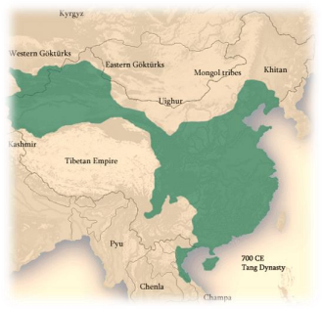

Wu Zetian lived from 624 to 705 CE and remains one of the most fascinating figures in Chinese history. She rose to power during the Tang Dynasty and became the only woman to ever rule China as emperor in her own name. Her reign marked a dramatic and often controversial chapter in Chinese history — full of brilliance, reform, and ruthless ambition.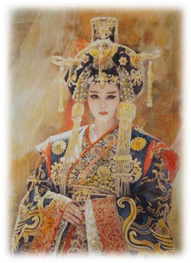

To some, Wu Zetian is a hero. During her rule, China experienced a flourishing of art, literature, and culture. Women’s education was promoted, and girls in elite circles gained access to opportunities once reserved for boys. Women could participate in activities like horseback riding, previously considered masculine. Wu also strengthened the military and expanded China’s borders. She earned respect as a shrewd and capable leader who often promoted officials based on merit rather than noble birth — a revolutionary idea at the time. While she ruled with a firm hand, that level of harshness was typical of the era. Many historians believe the criticism she received was magnified simply because she was a woman.

To others, Wu Zetian was a villain. Her rise to power involved intrigue, manipulation, and possibly murder — including accusations that she killed rivals, even members of her own family, to secure the throne. Ancient accounts describe her as having “a heart like a serpent and a nature like that of a wolf.” Critics argue that while she opened some doors for women, her reforms mostly benefited the elite and did not lead to widespread equality. Her reputation has been debated for centuries, with some questioning whether power came at too high a cost.

In the end, Wu Zetian defied every expectation placed on women of her time — and rewrote what was possible. Whether remembered as a hero, a villain, or something in between, her story forces us to ask: Can a ruler be both ruthless and revolutionary? And how do we judge women in power differently from men?

### **Reading Comprehension Questions (Wu Zetian)** Pick one, write in notebook, 2-4 full sentences answering

1. When did Wu Zetian live, and what dynasty did she rule? What made Wu Zetian unique among Chinese rulers?
2. Why do some people view Wu Zetian as a hero? What are some reasons people might consider Wu Zetian a villain?
3. List two major accomplishments of Wu Zetian’s reign. What criticism did ancient historians give Wu Zetian, and how might gender have played a role?

### **Critical Thinking Questions** Pick one, write in notebook, 2-4 full sentences answering

1. Can someone be both a hero and a villain in history? Use Wu Zetian as an example.
2. How might the way Wu Zetian was judged be different if she were a man?
3. Do you think Wu Zetian’s actions were justified for someone trying to maintain power in her time?
4. Why is it important to question historical sources when learning about figures like Wu Zetian?

| **Leader** | **Country/ Empire** | **Time** | **Leadership Style** | **Impact on Society** | **Treatment of Others** | **Legacy** |
| --- | --- | --- | --- | --- | --- | --- |
| Wu Zetian | Tang Dynasty, China | 624– 705 | Centralized, authoritative; promoted based on merit | Cultural growth; women's education; expanded empire | Accused of being ruthless to rivals | First and only female emperor in China |
| Mansa Musa | Mali Empire, West Africa | ~1280–1337 | Wealthy, devout Muslim; generous and diplomatic | Boosted education and trade; built mosques and schools | Famous for generosity during pilgrimage | Considered the richest man in history |
| Genghis Khan | Mongol Empire | 1162– 1227 | Military genius; united tribes; brutal conqueror | Trade routes protected; cultural exchange encouraged | Known for destruction in wars | Created the largest land empire in history |

**Discussion or Writing Prompts**

Which of the three rulers do you think had the most lasting impact on the world? Why?

Compare Wu Zetian’s leadership to Mansa Musa’s. How were their goals or methods different?

Genghis Khan and Wu Zetian were both seen as ruthless. Why might one be remembered more harshly than the other?

Imagine a conversation between Wu Zetian and Mansa Musa. What might they admire or criticize in each other’s leadership?