**Primary Source A: The Cornerstone Speech (1861)**

The CSA’s Constitution was almost identical to the USA’s constitution. The only major difference was that it forbade the country from ever abolishing slavery.

Alexander H Stephens, Vice President of the Confederate States of America, 1861:

*“The constitution…ideas… were fundamentally wrong. They rested upon the assumption of the equality of races. This was an error…Our new government is founded upon exactly the opposite idea; its foundations are laid, its corner- stone rests, upon the great truth that the negro is not equal to the white man; that slavery subordination to the superior race is his natural and normal condition.”*

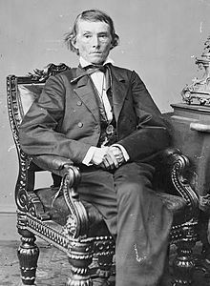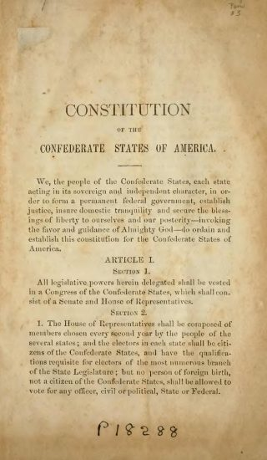

**Primary Source B: Georgian Declaration of Secession (1861)**

*“The people of Georgia having dissolved their political connection with the Government of the United States of America...*

*For the last ten years we have had numerous and serious causes of complaint against our non-slave-holding…*

*States with reference to the subject of African slavery.*

*They have… outlawed $3,000,000,000 of our property in the common territories of the Union because they give sanctuary to thieves…”*



**Primary Source C: Mississippi Declaration of Secession (1861)**

*“We embrace the alternative of separation; and for the reasons here stated:*

*Our position is thoroughly identified with the institution of slavery-- the greatest material interest of the world. None but the black race can bear exposure to the tropical sun. These products have become necessities of the world, and a blow at slavery is a blow at commerce and civilization. It has nullified the Fugitive Slave Law in almost every free State in the Union.*

*It [the North] advocates negro equality, socially and politically… to ruin our agriculture… and to destroy our social system.*

*We must either submit to degradation, and to the loss of property worth four billions of money.”*

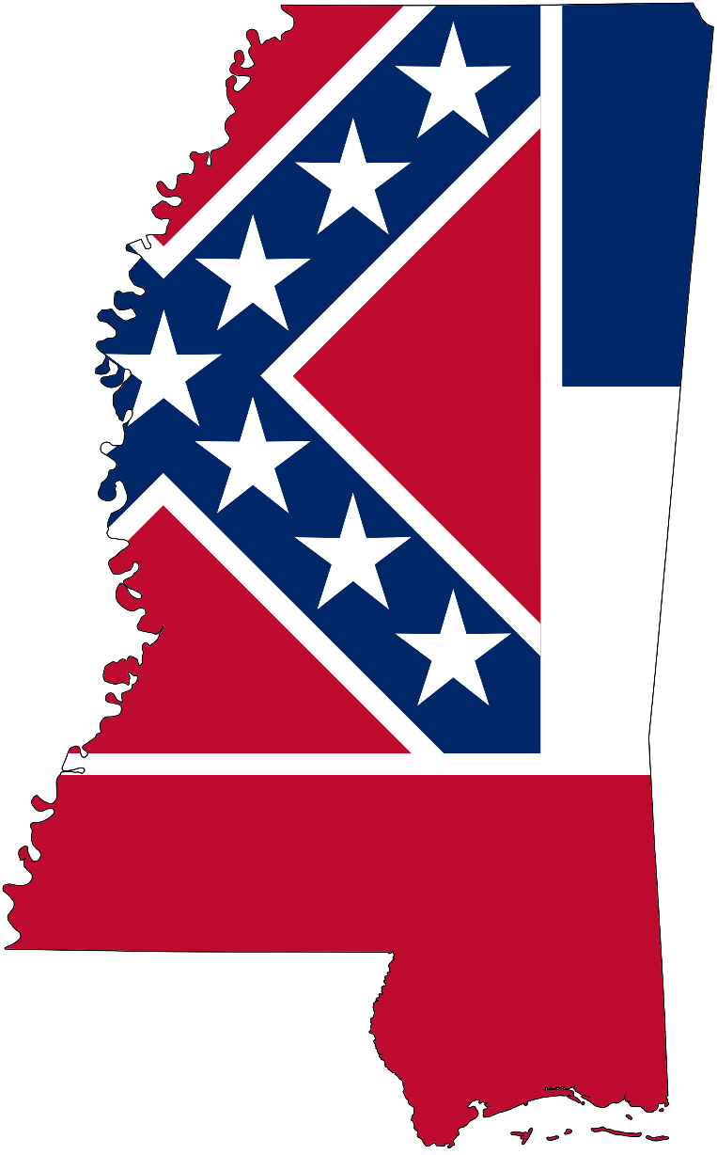

**Primary Source D: South Carolina Declaration of Secession (1861)**

*“The General Government, as an increasing hostility on the part of the non-slaveholding States to the institution of slavery, has led to a disregard of their obligations of fugitives from justice from the other States.*

*The right of property in slaves was recognized by giving to free persons distinct political rights.*

*The slaveholding States will no longer have the power of self-government, or self-protection, and the Federal Government will have become their enemy.”*

**

**Primary Source E: Texas Declaration of Secession (1861)**

*“We hold as undeniable truths that the governments of the various States, and of the confederacy itself, were established exclusively by the white race; that the African race… regarded as an inferior and dependent race…and justified by the… will of the Almighty Creator, as recognized by all Christian nations.”*

**