### **Summary of the US-China Trade War**

**What is the US-China Trade War?**The US-China trade war is a disagreement that started in 2018. The United States and China placed tariffs (extra taxes) on goods they traded with each other. It was about making trade more “fair” between the two countries.

### **Key Points:**

1. **Why Did It Start?**
   * The US said China was:
     + Copying American ideas and technology without permission.
     + Giving extra help (subsidies) to Chinese businesses to make them stronger.
     + Selling more to the US than it was buying (a trade imbalance).
2. **What Happened?**
   * The US added tariffs to Chinese goods (like electronics and clothes).
   * China responded by adding tariffs to US goods (like soybeans, cars, and machines).
   * Tariffs kept increasing, making products more expensive.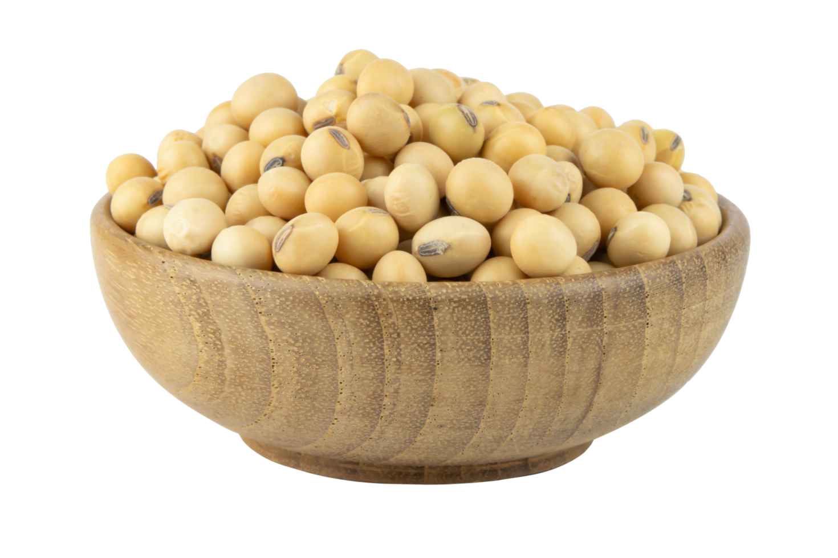
3. **How Did It Affect the US?**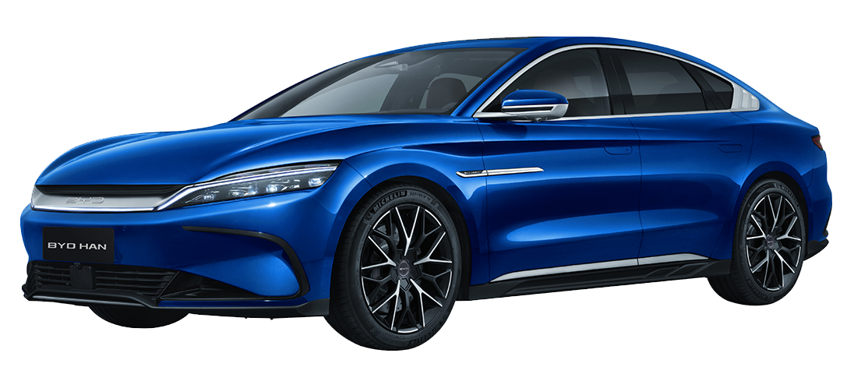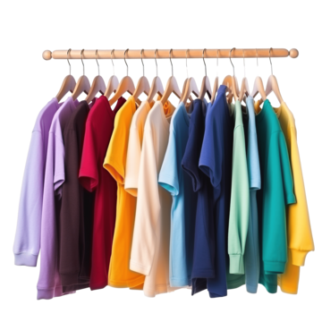
   * **Good:** Some American factories and workers (like steel workers) were protected from cheaper Chinese goods.
   * **Bad:** Many things became more expensive for US buyers. Farmers were hurt because China stopped buying as much from them.
4. 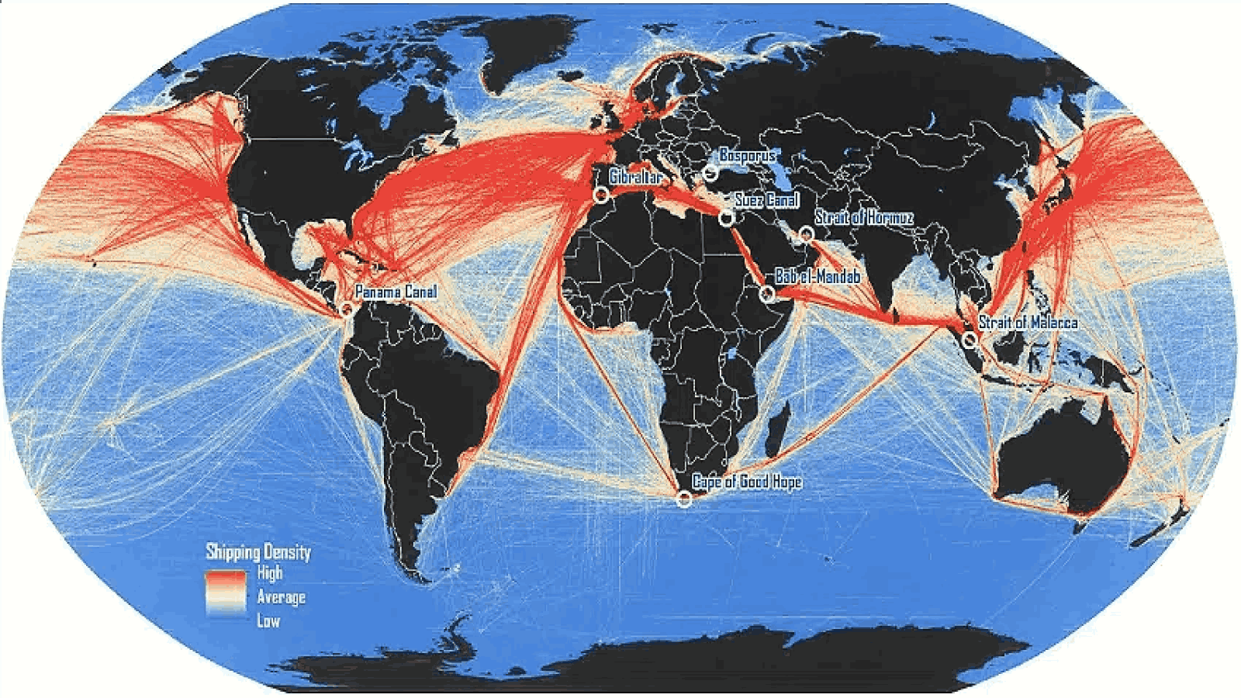**How Did It Affect China?**
   * **Good:** China started trading with other countries and investing in its own industries.
   * **Bad:** China’s economy grew slower, and some workers lost jobs because they couldn’t sell as much to the US.
5. **How Did It Affect the World?**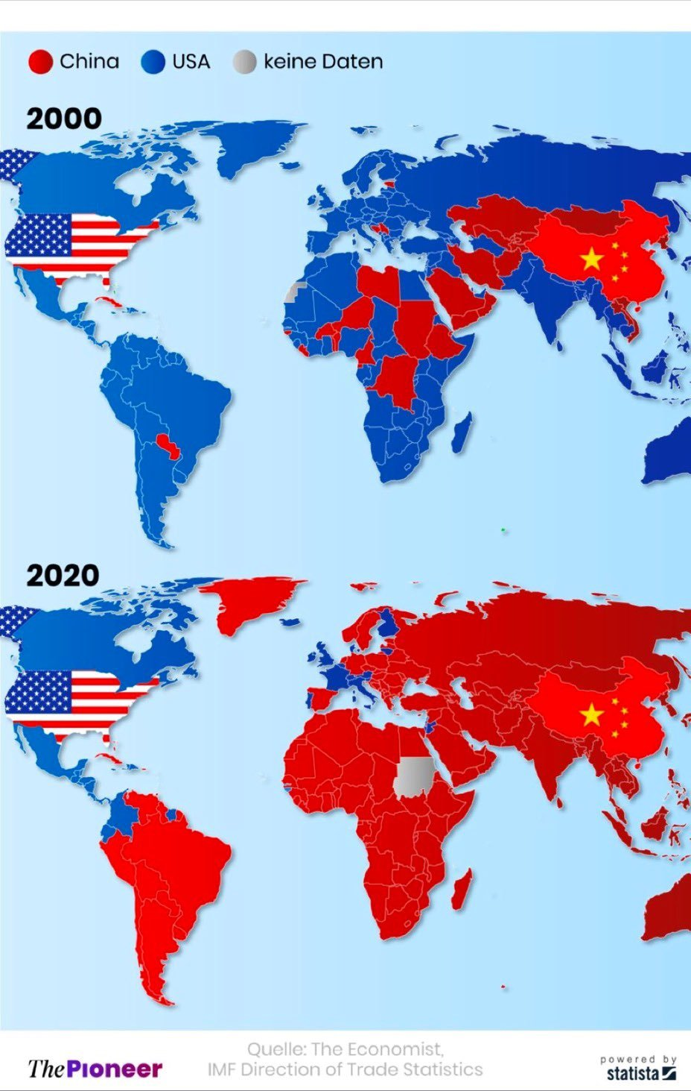
   * Global trade became harder because companies had to change where they got and sold products.
   * Other countries, like Canada and Mexico, were also hurt because of less trade.
6. **What’s Happening Now?**
   * Some tariffs are still in place, but the two countries are trying to talk and fix the problem.
   * They still have disagreements, especially about technology and global competition.

### **Why It’s Important:**

The trade war showed how connected countries are in the global economy. It also taught how tariffs can protect local businesses but hurt consumers and trade relationships.

**Final Question: What do you think about Tariffs?**