**Grade 7: Individuals and Societies**

Unit 4 Syllabus: The Tragedy of Diplomacy

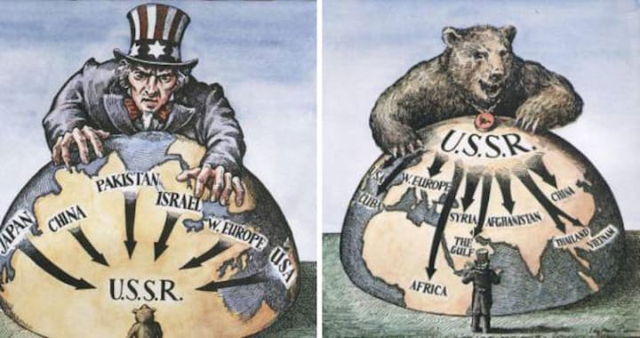

Students will explore diplomatic efforts that have led to war and peace through the following questions:

**Debatable Question:**

* Is war the fastest way to peace?

**Conceptual Questions:**

* How have peoples, boundaries, exchange, and interactions changed as a result of war?
* How have peoples, boundaries, exchange, and interactions changed as a result of peace?

**Factual Questions:**

* What caused the Second World War and the Cold War?
* What led to peace that ended the Second World War and Cold War?
* How did power change global interactions during the Second World War and Cold War?

**Statement of Inquiry:**

* The power to facilitate war and peace is influenced by boundaries that enforce global interactions.
* Global Interactions (Key Concept), Power (Related Concept), Orientation in Space and Time: Peoples, boundaries, exchange, & interactions (Global Context).

**Assessments:**

* Students will participate in two Debates set in the International Court of Justice arguing in favour of either continuing a war or enforcing a ceasefire:
  + Choice 1: Ukraine VS Russia
  + Choice 2: Rwanda VS Congo
  + Choice 3: Venezuela VS Guyana
* Students will be assessed on Criteria B (Investigating) and Criteria D (Critical Thinking). Details of this assessment are explained in the task sheet on Toddle.

| **Unit Calendar** | | |
| --- | --- | --- |
| Date | Lesson | Theme |
| AB: Wed 19 Mar  CD: Fri 21 Mar | L1: Introduction to Concepts | Second World War |
| AB: Fri 21 Mar  CD: Mon 24 Mar | L2: Second World War: Causes |
| AB: Tue 25 Mar  CD: Tue 25 Mar | L3: Second World War: Conflict |
| AB: Wed 26 Mar  CD: Fri 28 Mar | L4: Second World War: Peace |
| AB: Fri 28 Mar  CD: Tue 1 Apr | L5: Cold War: Causes | Cold War |
| AB: Tue 1 Apr  CD: Fri 4 Apr | L6: Cold War: Conflict |
| AB: Wed 2 Apr  CD: Mon 7 Apr | L7: Cold War: Peace |
| AB: Fri 4 Apr  CD: Tue 8 Apr | L8: Sample Debate | Summative |
| AB: Tue 8 Apr*  AB: Wed 9 Apr*  AB: Fri 11 Apr*  **AB: Tue 15 Apr**  **CD: Fri 11 Apr\*\*** | L9: Summative Choices  *AB Grow Time  **ISSEA Game |
| AB: Wed 16 Apr  CD: Mon 14 Apr | L10: Research Question, Action Plan, & OPVL |
| AB: Tue 22 Apr  CD: Tue 15 Apr | L11: Research Question, Action Plan, & OPVL |
| AB: Wed 23 Apr*  CD: Tue 22 Apr | L12: Start Main Arguments  *Open House |
| AB: Fri 25 Apr  CD: Fri 25 Apr | L13: Continue Main Arguments |
| AB: Tue 29 Apr  CD: Mon 28 Apr* | L14: Continue Main Arguments  *Smith & Larson absent due to field trip |
| AB: Wed 30 Apr  CD: Tue 29 Apr | L15: Finish Main Arguments |
| **AB: Tue 6 May**  CD: Tue 6 May*  CD: Fri 9 May*  **CD: Mon 12 May** | L16: Respond to Formative Feedback  *CD Grow Time |
| AB: Wed 7 May  CD: Tue 13 May | L17: Practice Rebuttals |
| AB: Fri 9 May*  **AB: Tue 13 May**  **CD: Fri 16 May** | L18: First Debate  *MAP Test |
| AB: Wed 14 May  CD: Mon 19 May | L19: Second Debate |
| AB: Fri 16 May  CD: Tue 20 May | L20: Third Debate |
| AB: Tue 20 May  CD: Fri 23 May | L21: Reflection |
| **AB: Wed 21 May**  **AB: Fri 23 May**  AB: Tue 3 Jun*  AB: Wed 4 Jun*  **CD: Mon 26 May**  **CD: Mon 2 Jun**  **CD: Tue 3 Jun** | L22: Hidden Figures Film  *AB Grow Time |