MS Summative Assessment Task Sheet | 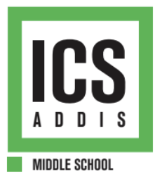

Grade: 6  Unit Title: Judging Controversy  Formative Due date: Apr 17 (AB) Apr 15 (CD)  Summative Due date: May 23 (AB) May 22 (CD) | Summative Assessment Title:  Judging Controversy Debate and Argumentative Essay

Task Description and Relationship to Statement of Inquiry:
Goal: To judge someone from the past as either mostly a hero or a villain.
Role: You are a judge.
Audience: G6 students.
Scenario: You will be assigned to argue that someone from the past is a hero or a villain (this is not your actual personal opinion) and then you will get to write your personal opinion in an essay format.
Performance: Debate and Argumentative Essay.
Relationship to Statement of Inquiry: The statement of inquiry, "Our values, philosophies, and ways of life may change over time, as do our perspectives," directly connects to the summative assessment by challenging students to critically evaluate historical figures through both contemporary and historical lenses. As societal norms and ethical standards evolve, people may be judged differently today than they were in their own time. In their three-paragraph essay, students will apply critical thinking skills to assess both the positive and negative contributions of these individuals, demonstrating their ability to balance historical context with modern perspectives. This deep analysis will then extend into a debate, where students, roleplaying as lawyers, will defend or critique the legacy of these figures. This debate will require students to construct persuasive arguments, reflecting how interpretations of historical figures shift over time as values and philosophies change.
Instructions for students: We will support you during each lesson on how to write your essay and how to prepare for the debate. We will spend one class on each paragraph and give you formative feedback. Once you are assigned your debate teams, then we will teach you debate skills to prepare for the final trial. For the debate you have 3 options:
1. Mahatma Gandhi
2. Winnie Mandela
3. Queen Elizabeth II
During the debate you will be assigned to argue that this person was either mostly a hero or a villain (this is not your personal opinion). When you write the essay, you will be allowed to choose any person and write your personal opinion. You may also choose to write about a person not listed above for your essay (but not for your debate). You will hand write it and then type it after teacher approval. This is a RED assignment so no AI is allowed.

Criteria & Strands:
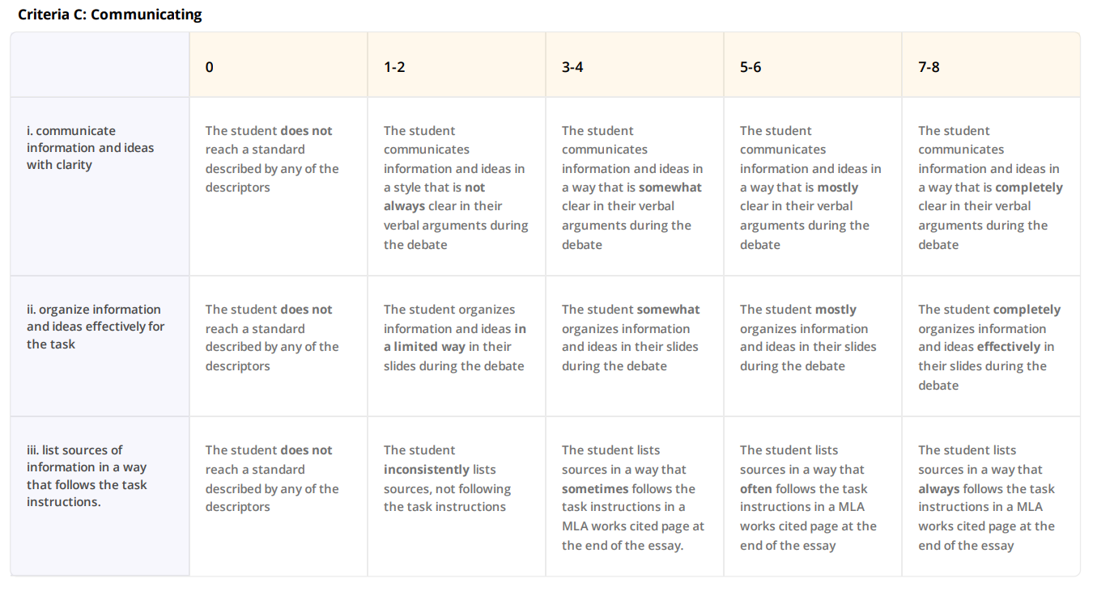
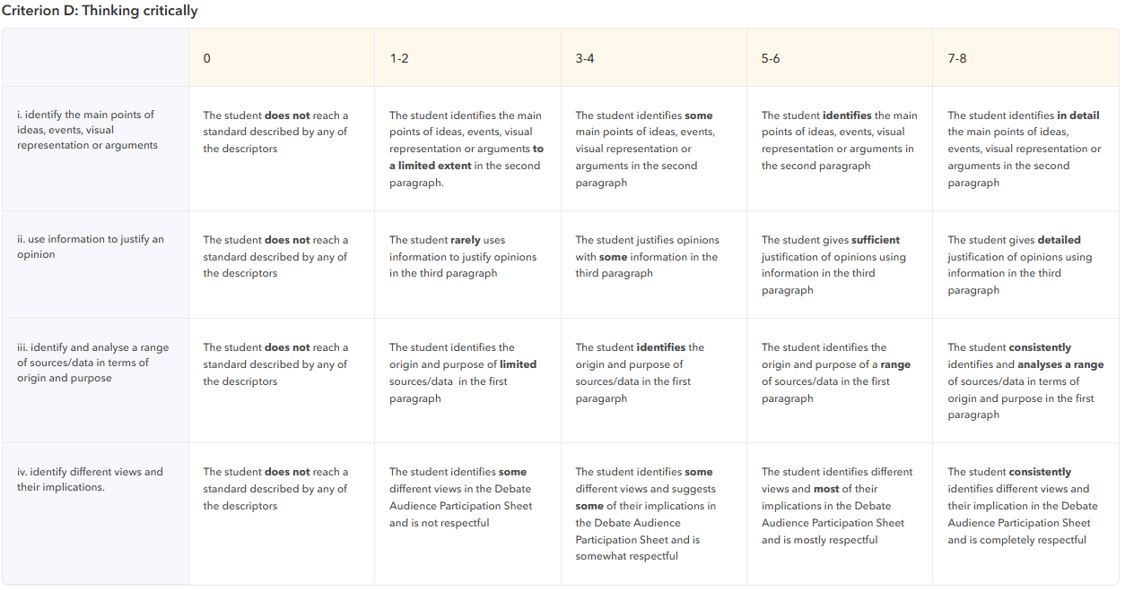

Sources:

Mahatma Gandhi: Source 1, Source 2, Source 3
Winnie Mandela: Source 1, Source 2, Source 3
Queen Elizabeth II: Source 1, Source 2, Source 3

Sentence Stems for Essay:

Paragraph 1 – Background & Source (Diii)
Let’s introduce the person and the source.
- This essay is about whether [name] was more of a hero or a villain.
- First, let’s learn more about [name].
- I read a source called [name of article or book], written by [author] in [year].
- This source was made to help people understand [purpose of source].

Paragraph 2 – Arguments from Different People (Di)
Show what others think — both good and bad.
- Some people think [name] was a hero because [reason 1].
- Another reason is [reason 2].
- But not everyone agrees.
- Some people say [name] was a villain because [reason 1].
- Others believe [reason 2].
Paragraph 3 – Your Opinion & Big Question (Dii)
Now it’s your turn — what do you think, and why does it matter?
- I think [name] was more of a hero/villain because [your strongest reason].
- This reason is stronger than others because [short explanation].
- This topic connects to the question:
➤ Should we be less judgemental of people from the past?
➤ Should we be more proud of strength or human rights?
➤ Is violence ever justified?
- I choose the question: [your chosen question].
- My answer is [your opinion] because [2-sentence explanation].

