**Grade 8: Individuals and Societies**

Unit 3 Syllabus: Unnatural Disasters

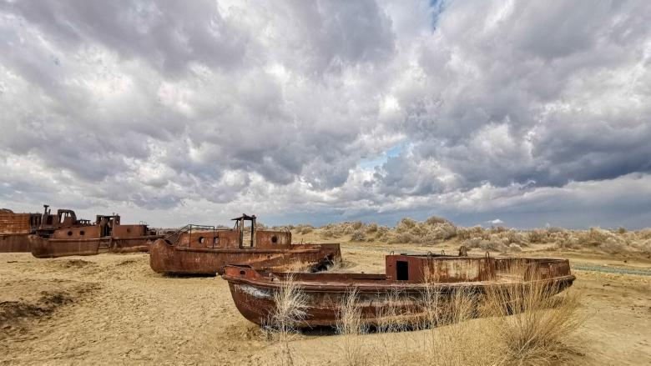

Students will explore the ways in which governments avoid blame by attributing disasters to natural causes through the following questions:

**Factual Questions:**

* In what ways was the Drying of the Aral Sea unnatural?
* In what ways was the Great Leap Forward Famine unnatural?
* In what ways was Disease in Bikini Atoll unnatural?
* In what ways was the Flooding of Abu Simbel unnatural?

**Conceptual Questions:**

* How do spectrums develop our nuance when evaluating natural and human landscapes?
* How do taboos limit our choices in regards to critical thinking?

**Debatable Question:**

* Are natural disasters ultimately unnatural?

**Statement of Inquiry:**

* Human choices to develop natural landscapes and resources are frequently unsustainable.
* Development (Key Concept), Orientation in Space and Time: Natural and Human Landscapes (Global Context), Choice and Sustainability. (Related Concept).

**Assessment Criterias C: Communication & D: Thinking Critically):**

* Students will be participating in a Socratic Seminar where they have to argue to what extent a disaster was natural or unnatural on 2 of the 4 options:

1. Dubai Floods of 2024.
2. Ethiopian Famine of 1984.
3. Drying of the Nile since 1956.
4. Great Influenza Pandemic of 1918.

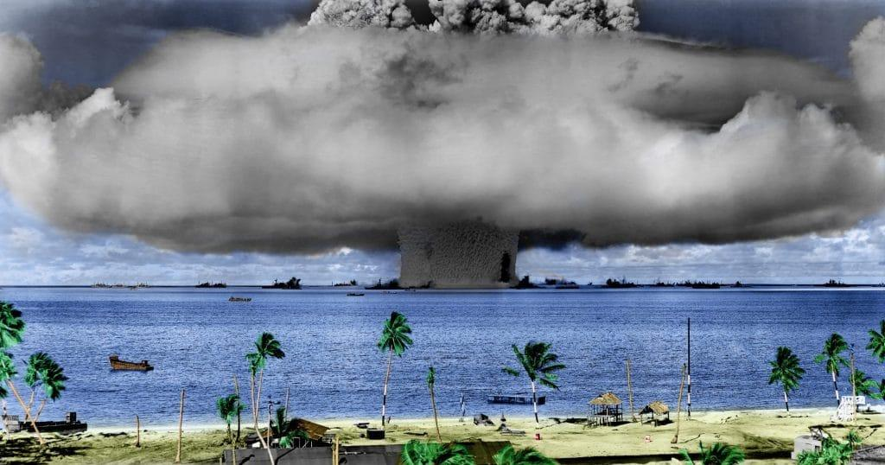

| **Unit Calendar** | | |
| --- | --- | --- |
| Date | Lesson | Theme |
| AB: Mon Jan 13  CD: Fri Jan 10 | L1: Introduction to Concepts | Case Studies |
| AB: Wed Jan 15 CD: Mon Jan 13*  CD: Thu Jan 16*  CD: Fri Jan 17*  CD: Mon Jan 20** | L2: Drying of the Aral Sea  *CD Grow Time  ***MYP Verification Visit |
| AB: Thu Jan 16  CD: Thu Jan 23 | L3: The Great Leap Forward Famine |
| AB: Mon Jan 20* CD: Fri Jan 24** | L4: Health Issues in the Marshall Islands  **LA Fires  *MYP Verification Visit |
| AB: Wed Jan 22 CD: Mon Jan 27 | L5: Flooding of Abu Simbel |
| AB: Thu Jan 23* CD: Thu Jan 30 | L6: Health Issues in the Marshall Islands  *LA Fires |
| AB: Mon Jan 27 CD: Fri Jan 31 | L7: Introduction to Socratic Seminars | Socratic Seminar Preparation |
| AB: Wed Jan 29 CD: Mon Feb 3 | L8: Introduction to Summative Topics |
| AB: Thu Jan 30 CD: Thu Feb 6 | L9: Summative Research |
| AB: Mon Feb 3 CD: Fri Feb 7 | L10: Summative Research |
| AB: Wed Feb 5 CD: Mon Feb 10 | L11: Prepare Comments |
| AB: Thu Feb 6 CD: Thu Feb 13 | L12: Prepare Comments |
| AB: Mon Feb 10*  AB: Wed Feb 12*  AB: Thu Feb 13*  AB: Mon Feb 17 CD: Fri Feb 14 | L13: Prepare Comments  *AB Grow Time |
| AB: Wed Feb 19 CD: Mon Feb 17 | L14: Practice Socratic Seminar |
| AB: Thu Feb 20 CD: Thu Feb 20 | L15: Respond to Formative Feedback |
| AB: Mon Feb 24  CD: Fri Feb 21 | L16: Respond to Formative Feedback |
|
|
| AB: Wed Feb 26*  CD: Mon Feb 24 | L17: First and Second Socratic Seminars  *Student Led Conferences |
| AB: Thu Feb 27*  CD: Thu Feb 27 | L18: Third and Fourth Socratic Seminars  *First and Second Socratic Seminars |
| AB: Mon Mar 3*  CD: Fri Feb 28 | L19: Reflection  *Third and Fourth Socratic Seminars |
| AB: Wed Mar 5*  CD: Mon Mar 3 | L20: Reflection  *Student Lead Conferences |
| AB: Thu Mar 6  CD: Thu Mar 6 | L21: Reflection |
| AB: Mon Mar 17  CD: Fri Mar 7  CD: Mon Mar 17* | L22: Reflection  *CD Grow Time |