**Grade 6: Individuals and Societies**

Unit 3 Syllabus: Local and Global Markets

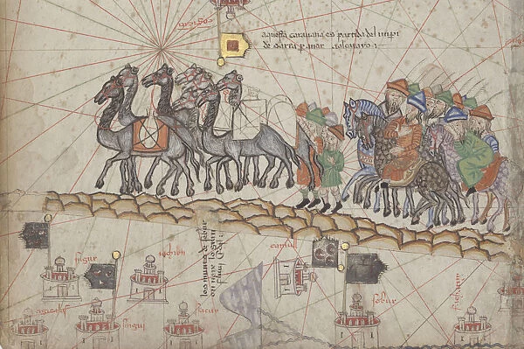

Students will explore the ways in which local businesses operate in Addis Ababa through tangible research as well as global businesses using a simulation of their own fictional company that will explore the following questions:

**Factual Questions:**

* What is the difference between production, distribution, and consumption?
* What are Markets and Commodities?
* What is Commercialisation?

**Conceptual Questions:**

* How are businesses localised and globalised?
* How does trade affect sustainability?

**Debatable Question:**

* What systems allow businesses to become successful?

**Statement of Inquiry:**

* Systems of trade can affect the sustainability of markets, commodities, and commercialisation.
* Systems (Key Concept), Markets, Commodities, and Commercialisation (Global Context), Trade and Sustainability (Related Concept).

**Assessment Part One (Criteria B: Investigating):**

* For Part One students will produce their own research questions in regards to the systems of production, consumptions, distribution as well as globalization and sustainability. They will develop an action plan to decide how they will conduct an investigation to research a local business at the ICS Community Market Saturday, January 25 and will collect and record relevant information when conducting their interviews. They will then transcribe their research in order to reflect on their process and results of their investigation to their classmates. Students will be assessed on Criteria B (Investigating).

**Assessment Part Two (Criteria A: Knowing and Understanding):**

* For Part Two, students will create their own fictional business and go through multiple simulations and apply the concepts and vocabulary to their businesses. This way, students will not only learn vocabulary in isolation but rather how it would operate in this theoretical simulation. Students will be assessed on Criteria A (Knowing and Understanding).

| **Unit Calendar** | | | | |
| --- | --- | --- | --- | --- |
| AB Date | AB Lesson | CD Date | CD Lesson | Theme |
| AB: Fri Jan 10 | Introduction to Scarcity | CD: Mon Jan 13 | Introduction to Scarcity | Investigating A Real Business |
|
| AB: Tue Jan 14 | Introduction to Concepts | CD: Tue Jan 14 | Introduction to Concepts |
|
| AB: Thu Jan 16 | Introduction to 1st Summative: Investing a Real Business | CD: Thu Jan 16 | Introduction to 1st Summative: Investing a Real Business |
|
| AB: Fri Jan 17 | Interview Practice | CD: Mon Jan 20* | Interview Practice  *MYP Verification Visit |
|
| ABCD:  Sat Jan 25 | **Community Market** | CD: Tue Jan 21* | NGOs  *MYP Verification Visit |
|
| AB: Tue Jan 28  Tue 21*, Thu 23*, Fri 24* | Transcribing Interviews  *AB Grow Time | CD: Thu Jan 23 | Catchup |
|
| AB: Thu Jan 30 | Respond to Formative Feedback | ABCD: Sat 25 | **Community Market** |
|
| AB: Fri Jan 31 | Respond to Formative Feedback | CD: Mon Jan 27 | Transcribing Interviews |
| AB: Tue Feb 4* | Presenting Reflection Slides  *Smith absent due to CPR | CD: Tue Jan 28 | Creating Reflection Slides |
| AB: Thu Feb 6 | Presenting Reflection Slides | CD: Thu Jan 30 | Respond to Formative Feedback |
|
| AB: Fri Feb 7 | Introduction to 2nd Summative: Creating your Business | CD: Mon Feb 3 | Presenting Reflection Slides |
| AB: Tue Feb 11 | Supply and Demand: Stations Activity | CD: Tue Feb 4* | Presenting Reflection Slides  *Smith absent due to CPR |
| AB: Thu Feb 13 | Supply and Demand:  Breaking News & Stock Market 1 |
| AB: Fri Feb 14 | Public and Private: Stations Activity | CD: Thu Feb 6 | Introduction to 2nd Summative: Creating your Business | Creating Your Own Business |
| AB: Tue Feb 18 | Public and Private:  Breaking News & Stock Market 2 | CD: Mon Feb 10 | Supply and Demand: Stations Activity |
| AB: Thu Feb 20 | **Study Hall / Portfolio Work Day**  **\*Larson & Smith Absent** | CD: Tue Feb 11 | Supply and Demand:  Breaking News & Stock Market 1 |
|
| AB: Fri Feb 21 | Sustainability: Stations Activity & Writing | CD: Thu Feb 13 | Public and Private:  Stations & |
|
|
| AB: Tue Feb 25 | Sustainability: Breaking News & Stock Market 3  *L & S Absent due to GLL Meeting | CD: Mon Feb 17 | Public and Private:  Breaking News & Stock Market 2 |
|
|
|
| AB: Thu Feb 27* | Shark Tank Pitch Preparation & Formative Feedback  *Block 4/5 Art Trip | CD: Tue Feb 18 | Sustainability: Stations Activity & Writing |
| AB: Fri Feb 28 | Shark Tank Pitch Preparation | CD: Thu Feb 20 | **Study Hall/Portfolio Work Day**  **\*Larson & Smith Absent** |
| AB: Tue Mar 4 | Shark Tank Pitch Preparation | CD: Mon 24*  Tue 25* Thu 27*, Mon Mar 3 | Sustainability: Stock Market 3  *CD Grow Time |
| AB: Thu Mar 6 | Shark Tank Pitch Presentations | CD: Tue Mar 4 | Shark Tank Pitch Preparation |
| AB: Fri Mar 7* | Reflection  *Larson Absent | CD: Thu Mar 6 | Shark Tank Pitch Preparation & Formative Feedback |
| AB: Tue Mar 18* | Reflection  *Larson & Smith Absent for GLL Planning Day | CD: Mon Mar 17* | Shark Tank Pitch Presentations  *Larson Absent |
| AB: Tue 25*  Thu 27*, Fri 28* | *GROW TIME (AB) | CD: Tue Mar 18 | Study Hall |
| CD: Thu Mar 20 | Shark Tank Pitch Presentations |
| CD: Mon Mar 24 | Reflection |